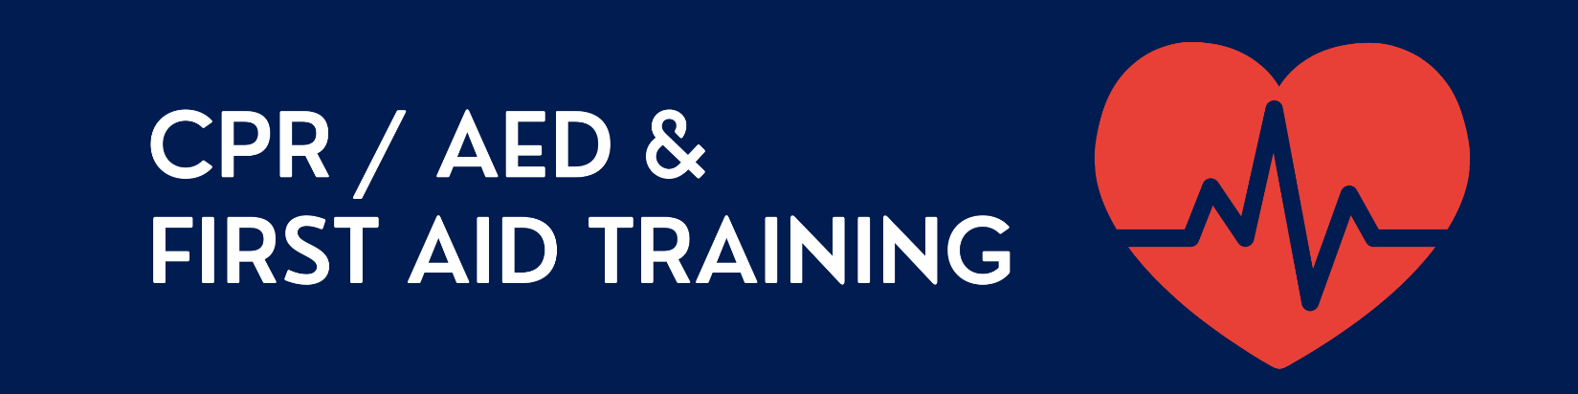

When (select a session*):  Sunday, February 16, 2025, at 10:00 a.m. to 4:00 p.m.  Saturday, March 15, 2025, at 10:00 a.m. to 4:00p.m.  Sunday, March 16, 2025, at 10:00 a.m. to 4:00 p.m.  Saturday, April 19, 2025, at 10:00 a.m. to 4:00 pm. | Location:  Pacific College of Health and Science  110 William Street, 19th Floor, Room 5  New York, NY 10038
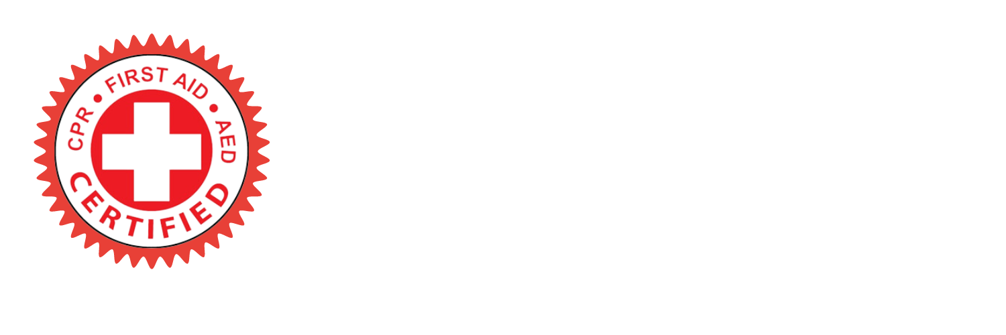
*All sessions will be held on-ground/in-person. Sessions are subjected to cancellation if the 6-registrant minimum requirement is not met. Each session will be maxed at 12 participants. Sessions will run approximately 5-8 hours.

The American Heart Association has also developed new guidelines in respect to CPR, AED and First Aid training. We will be offering Adult/Child/Infant CPR/FA courses online in compliance with PCHS and AHA guidelines.

Costs:
$95 for CPR/AED and First Aid training. All payments are due on the day of class. Venmo, Paypal, and Zelle are accepted. If you are unable to pay via the preferred methods, please contact the instructor to discuss options.

How to Register:
Please send an email to Dorothy Wong at acuwong@gmail.com. Be sure to include the date and time of the session that you would like to enroll in, along with your full name and phone number.
RSVP NOW AT: acuwong@gmail.com

See you there!

